camera ready manuscript Guidelines for

the TEHNOMUS

Author¹, Author^{2,} Author³

¹Affiliation, e-mail.
^{2,3}Affiliation, e-mail.

Abstract: This sample article provides information and instructions for preparing in a standard format the papers to be included in the Volume of the TEHNOMUS Conference. It illustrates the paper layout, and describes points you should notice before you prepare your paper. In order to enable the publisher to bring the article into the uniform layout and style, authors are kindly requested to follow the instructions given below.

Keywords: keywords list (max. 5)

1. Title of Section (e.g. General Introduction)
Each paper must be typed on white paper sheets of A4 size (210mm 297mm) on one side only. The paper should be prepared with an electronic text processing system. We strongly recommend the use of Microsoft Word processing system.
Copies of manuscript should be sent by email to the Secretariat at tehnomus@usm.ro
2. Preparation of the Camera Ready Paper
The paper should be typed using 12pt size Times New Roman letter with single spacing between text lines. The upper and lower margin should be 27mm, the left and right one 20mm.
New paragraphs are to be indented 5mm from the left-hand margin, with no extra space between paragraphs.
2.1 Front Matter

2.1.1 Title, affiliation(s), abstract and keywords

The first line of title is located 2 lines (20pt) from the top of printing box. This space is reserved for Editorial Heading.
The title of the paper should be written centered, single spaced, in 14pt size bold capital letters. The title must not exceed three lines. The author's name should include first and middle (if any) name initial, and surname. It should be written centered, in 12pt size bold face letter, one line (12pt) below the title.
The title of authors and their e-mail address should appear on the bottom of paper title. Author's affiliation should be written centered, in 11pt size italic letter with one line (12pt) space below the list of authors. Following the author's names and affiliations put the abstract no more than 150 words. Set up additional 10mm left and right margins.
The abstract should be written in 11pt size letter with one line (12pt) space below the affiliations. Please, write no more than five keywords. The 12pt space should separate the keywords line from the abstract.
This line should be written left aligned to the margin of abstract and must begin with words ‘Keywords:’ written in the normal 11pt size bold letter. Keywords should be written in 11pt size, italic letter (see above).
2.2 Diagrams, Tables and Figures

Care should be taken over the preparation of diagrams, tables and figures. Tables must be set as part of the text. All tables must have a caption centered over the table and should be numbered sequentially and start with ‘Table x:’ (x stands for a number), TNR10.
Figures will either be entered in one column or two columns and should be 80mm or 170mm wide respectively. A minimum line width of 1pt is required at actual size. Annotations should be in 10pt with the first letter only capitalized. All figures should be numbered sequentially and captioned. The caption should be written centered below the figure and start with ‘Figure x:’ (x stands for a number). Figures should be embedded in the document. Please leave an extra space of 10pt before and after each table and figure.
Example of Fig. 1:
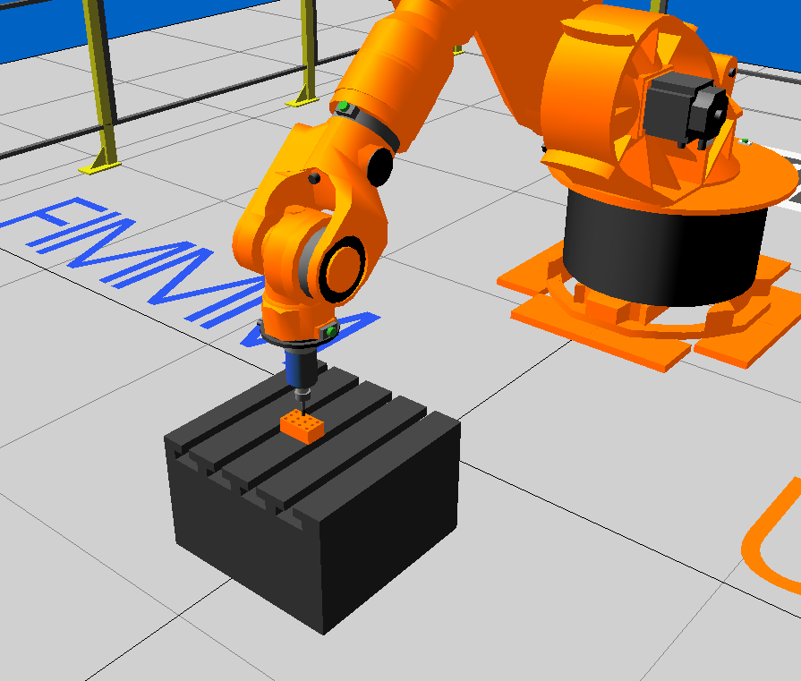
Figure 1: Virtual drilling application process with Kuka Kr125 robot help develop with specialized Kuka SimPro software.
2.3 Equations

Equations should be prepared in Word with the appropriate equation editor. Each equation should occur on a new line with uniform spacing (12pt) from adjacent text as indicated in this template. The equations, where they are referred to in the text, should be numbered sequentially and their identifier enclosed in parenthesis, right justified as indicated below. The punctuation should be used in equations as they were regular sentences. Example:
E=mc². | (1)
Please pay attention that all variable references in text must be written the same style as in displayed equations.
The citation of figure(s), reference(s) and equation(s) have to be abbreviated as Fig. x; Ref. [x]; Eq. (x) or, in plural form, as Figs. x,y; Refs. [x,y]; Eqs. (x,y) - where x, y stand for a number. Above phrases are typed in full word when they appear as the first word of sentence. Citation of table(s) is always written in full word - Table x or Tables x, y. Please be consistent in the use of capital letters, abbreviations and punctuation.
2.4 Units

Please use SI – units throughout the paper.
3 General Style Preferences
3.1 Style of Writing
Papers are accepted on the basis that they match high international standards of scientific writing. The author himself is responsible for the correctness of the scientific content.

Abbreviations should be spelt out in full the first time they appear and their abbreviated form included in brackets immediately after. Do not use more than three level depth of headings.
3.2 Paper Length
The paper, including the title page, figures, tables should be not be less than four pages and not more than eight, in English
4 References
The papers in the reference list must be cited in the text. In the text the citation should appear in square brackets “[Ionescu,1996]”.
In the Reference list the font size should 11pt. Author names should be terminated by a ‘full stop’. The citation number should be enclosed in brackets.
The book titles should be in italics, followed by a ‘full stop’. Proceedings or journal titles should be in italics. For instance:
References
1. [Brebbia,1984] Brebbia, C.A., Telles, J.C.F. and Wrobel, L.C., Boundary Element Techniques, Springer-Verlag, Berlin and New York, 1984.
2. [Ionescu,1996] I o n e s c u, R., Roboţi industriali, Principii de bază si aplicaţii, Editura OID-ICM (Oficiul de informare documentară pentru industria constructoare de maşini), Bucureşti, 1996.
3. Portable Cardboard Table from Liborius Reykjavik Available from, http://www.inhabitat.com/2008/06/10/portable-flat-pack-cutting-table-from-liborius

Paper
Please follow the following submission method:

We request:
A source version of your paper formatted according to the Conference template in MS-Word processing system. Send the electronic versions of your paper as attachments to an email message sent to tehnomus@usm.ro

